Radstock & Westfield Partnership agreement

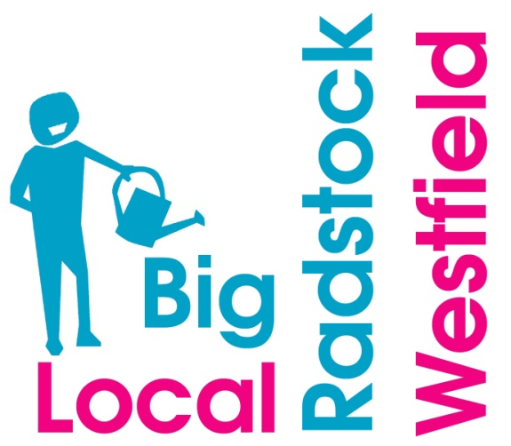

.

Invitation to join
The role of the Big Local Partnership is to guide and deliver the distribution of the lottery funding in a way that guarantees that the residents of Radstock and Westfield will benefit from its use.
Local organisations will work in partnership with Radstock & Westfield Big Local to ensure that any funding approved, is spent according to the criteria and terms and conditions.
If you wish to join the Partnership please familiarise yourself with the expectations below, and complete and return the attached form. You must be a resident of, or work in the area of, Radstock / Westfield. This includes Haydon, Clandown, Tyning and Writhlington.
Members of the Partnership will undertake to:
- Provide overall direction of Big Local (BL) to meet this community’s long-term vision and outcomes.

- Support the delivery of the BL plan in order to achieve the shared vision.

- Work in partnership with the management team to ensure the themes of the plan are met.

- Contribute to the annual review and help adapt the plan according to the needs of local residents.

- Ensure that local residents are aware of what is being achieved by spreading the good news using word of mouth and/or social media.

- Monitor and gain understanding of the effect of allocation of the Lottery monies and provide any feedback to Local Trust via the community workers.

- Be committed to promoting equality and equal access to all and to engaging and empowering the whole of the community.

- Adopt the code of conduct for partnership members. We are committed to strive for quality and excellence in everything that we do.

- Enable residents and people locally to improve their own communities through solving their community issues.

- Actively share knowledge and skills, and promote the development of skills and ability.

Please complete form below in order to join the Radstock & Westfield Big Local Partnership
Name:
Address:
Postcode:
Contact telephone number:
Email address:
Signature:

Please indicate the skills you are able to offer to the Partnership:

Please return this completed sheet to:
- Oval Office, Cobblers Way, St Peter’s Business Park, Westfield, BA3 3BX
- info@radstockwestfield.org.uk
The Radstock & Westfield Big Local management team invite local residents to join the Partnership, to ensure the plan is delivered over the 10 year programme and into the future.
We will not tolerate behaviour that produces damaging or hurtful effects, physically or emotionally other people.
Thank you for your time and we look forward to working with you.

