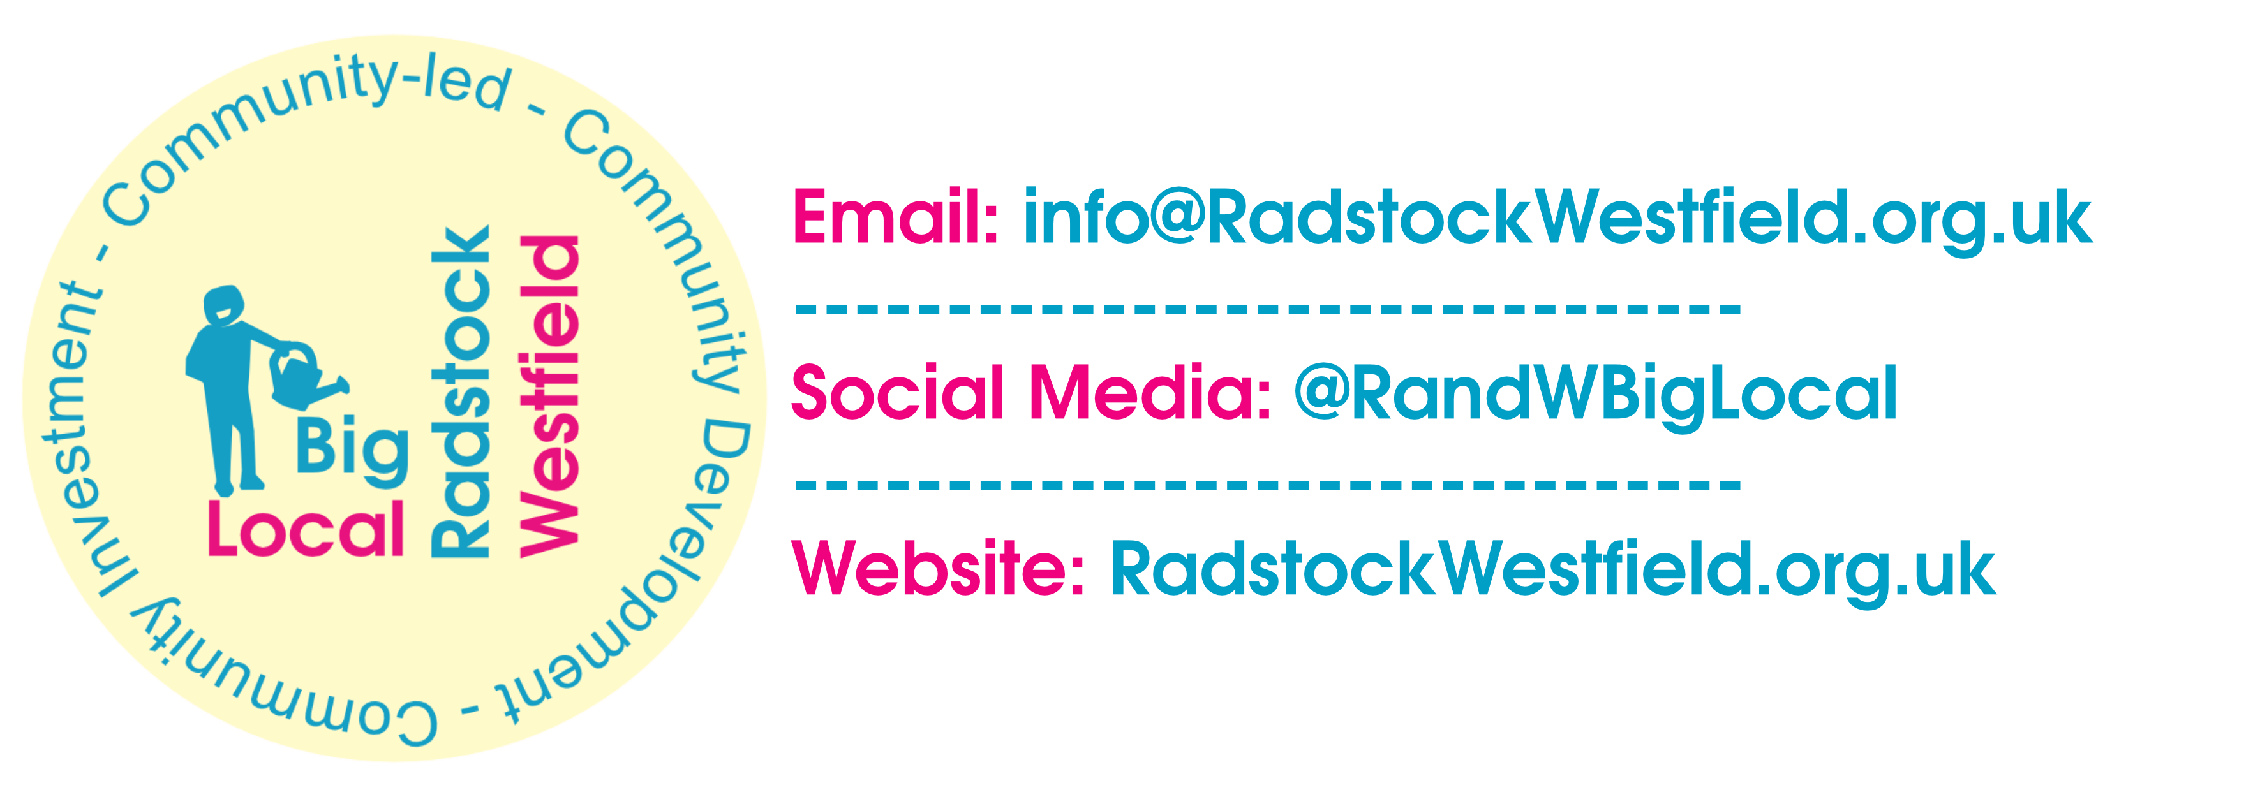
Dragons’ Den 8 ~ Application Form 2022
- Taking place on 1st July at Whisty Hall, 4pm until 7pm -
Applicant name (and organisation if applicable):
Type of applicant: Association Charity CIC Individual Other
Address:
Email:
Phone:
Names of people pitching:
- Name of Project/Idea:
- How much funding are you applying for? (up to £500)
- What will your project/idea do?
- Why is your project needed / how will it benefit residents of Radstock/Westfield?
- Please provide an estimated project budget:
- Is there anything else you want to tell us?

- Signature & date:

RETURN TO: robwicke@radstockwestfield.org.uk
Thank you for taking the time to complete your application to pitch at the 8th Radstock & Westfield Big Local Dragons' Den. Please remember to save the date of the 1st July 2022

