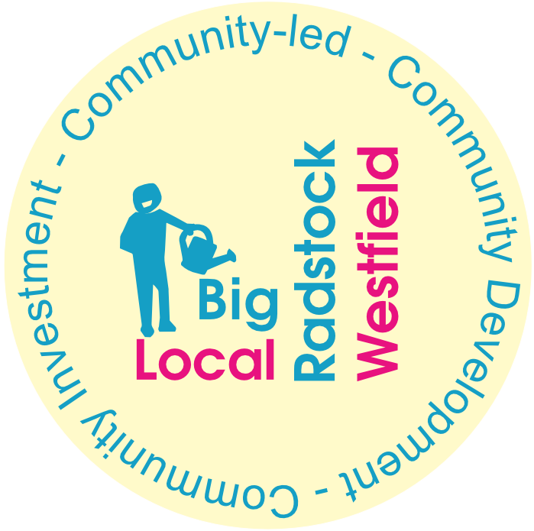
Community Group:
Responsible person:
Address:
Email:
Phone:
Please provide the names of all committee members:

- Name of Project/Idea:
- How much funding are you applying for? (up to £500)
- How will your project increase resilience -either of the group or the community it serves?
- Is there anything else you want to tell us?

- Signature & date:

What Big Local funding cannot be used for, including: the costs of putting together your proposal; activities that happen or start before the grant is confirmed; expenses you commit to before Big Local confirms the grant; salaries of existing staff for activities they undertake as part of their normal employment that are not related to the project; political activities, as defined by the Charity Commission; religious activities, which includes the practice of religion or activities that actively promote religion or particular belief systems (or indeed the lack of belief); projects or activities which the state has a legal obligation to provide; VAT you can recover; general running costs not associated with the delivery of the project.
The Radstock and Westfield Big Local money must be invested to benefit residents within the Radstock and Westfield Ward boundaries.

