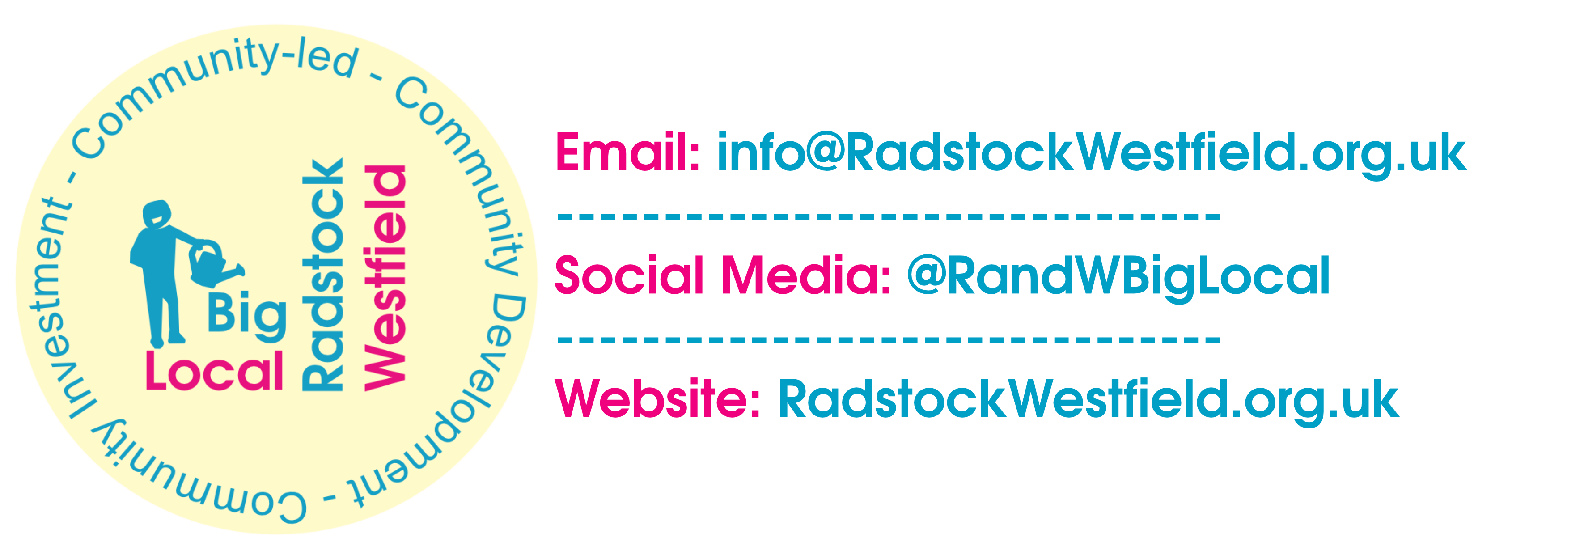
The Green Dragon - Dragons’ Den 9 ~ Application Form ~ 2023
- Taking place on Friday 21st April –
Timings: Set up possible from 4:30pm. Doors will open to public at 5pm, event starts 5:30pm.
Location tbc.
Application closing date: 5pm, 31st March.
Applicant name (and organisation if applicable):
Type of applicant: Association Charity CIC Individual Other
Address:
Email:
Phone:
Names of people pitching:
- Name of Project/Idea:
- How much funding are you applying for? (up to £500)
- Within the theme of the outdoor environment, how will your project benefit residents within Radstock/Westfield?
- Please provide an estimated total project budget:
- Is there anything else you want to tell us?

- Signature & date:

RETURN TO: robwicke@radstockwestfield.org.uk
Thank you for taking the time to complete your application to pitch at the 9th Radstock & Westfield Big Local Dragons' Den. Please remember to save the date of the 21st April 2023.

