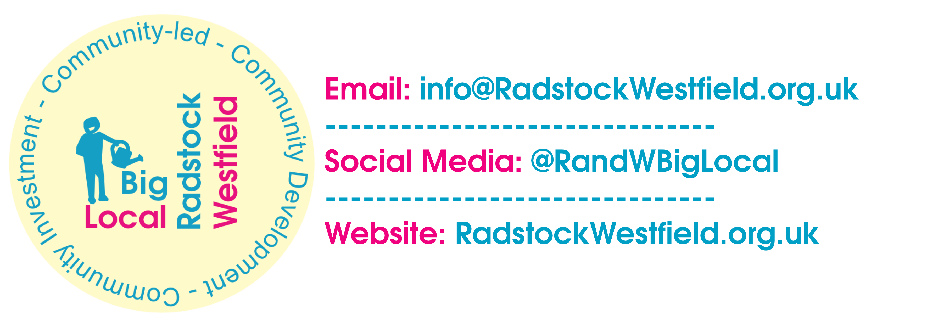
Dragons’ Den 11 ~ Application Form ~ 2024
- Taking place on Friday 15th Nov –
Timings: Set up possible from 5pm. Doors will open to public at 5.30pm, event starts 6pm.
Location: Westfield Sports and Community Centre, Westhill Road, BA3 3TE
Application closing date: 5pm, 28th Oct.
Applicant name (and organisation if applicable):
Type of applicant: Association Charity CIC Individual Other
Address:
Email:
Phone:
Names of people pitching:
- Name of Project/Idea:
- How much funding are you applying for? (up to £1,000)
- How will your project benefit residents within Radstock/Westfield?
- Please provide an estimated total project budget:
- Is there anything else you want to tell us?

- Signature & date:

RETURN TO: robwicke@radstockwestfield.org.uk
Thank you for taking the time to complete your application to pitch at the 11th Radstock & Westfield Big Local Dragons' Den.

